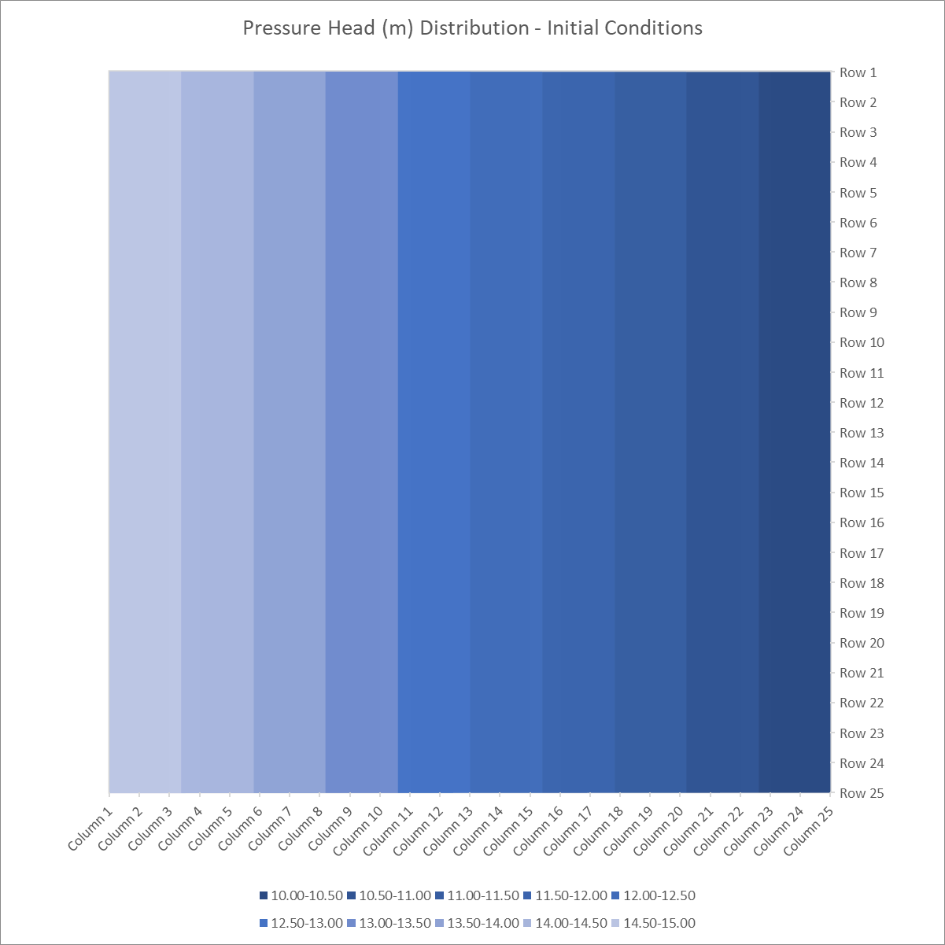

Figure : Homogenous Model from Initial Code, head contours at every 0.5 m change in head.

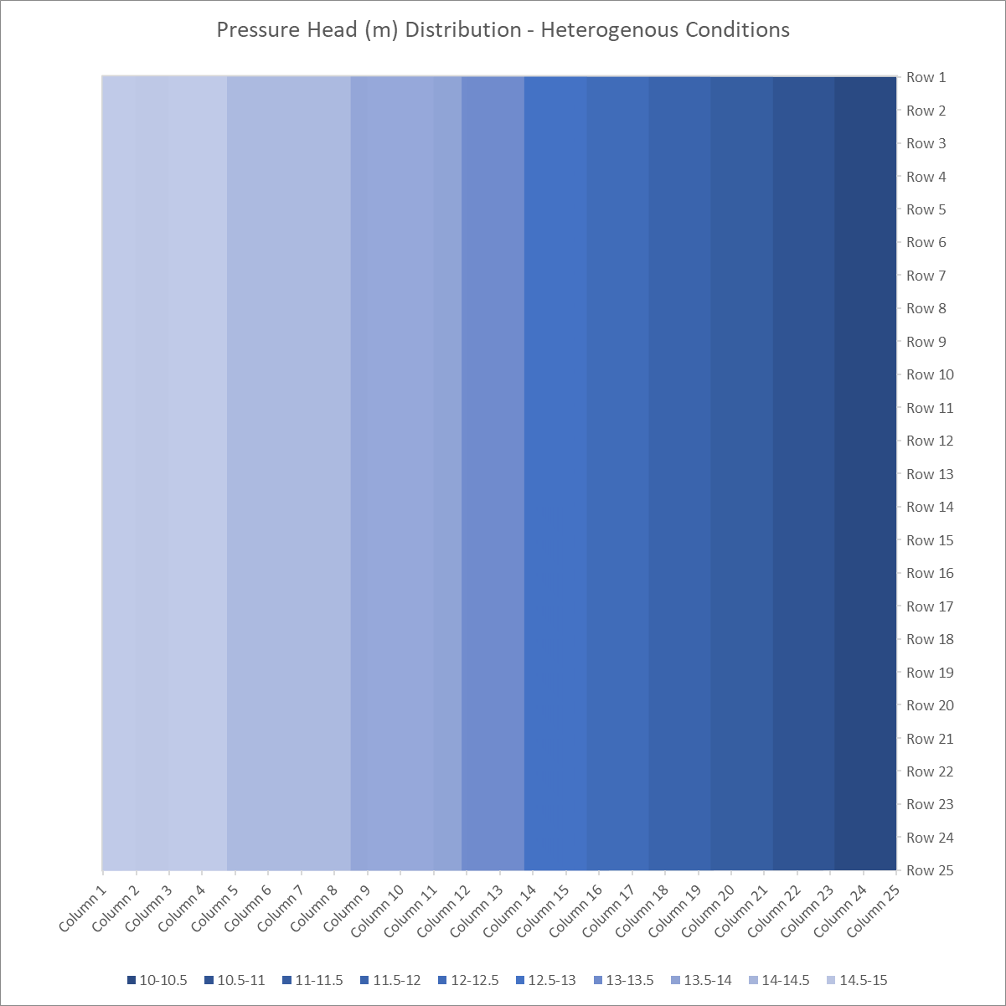

Figure : Heterogenous Model head contour graph, with the first 11 columns (left side) having a K of 1 m/d, and the remaining columns (12-25) having a K of 0.5 m/d. Darker shades of blue indicate a lower head value (Excel unfortunately does not have cool colormaps like the Python matplotlib module).

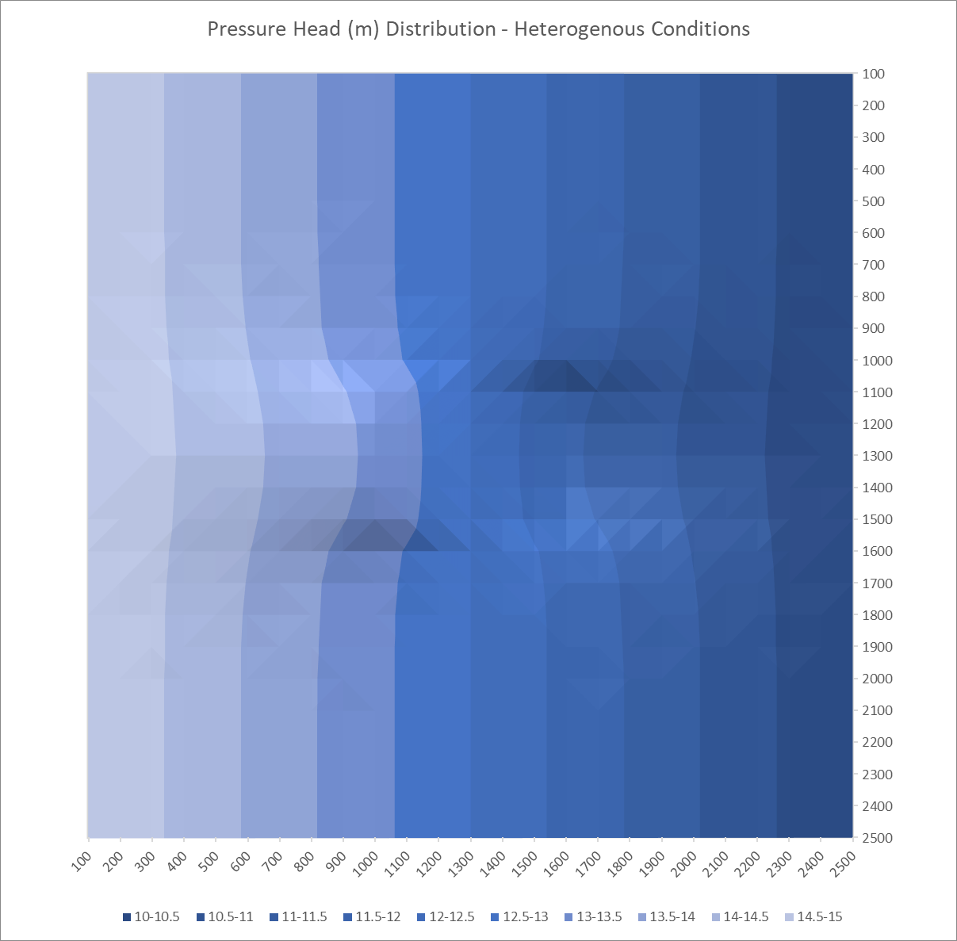

Figure : Inclusion Model head contour surface.

**\*\*\*ALL OF THE EXCEL ONES WERE UGLY, SO I DID THEM IN PYTHON\*\*\***

**\*\*\*SEE BELOW\*\*\***

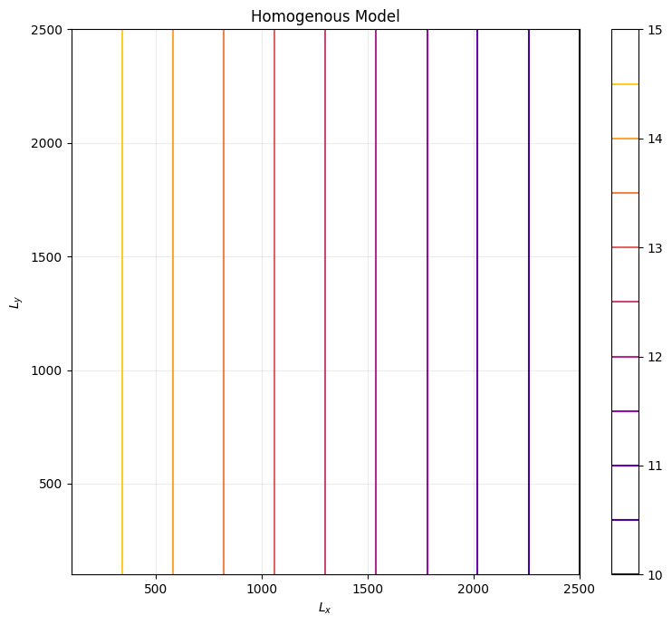

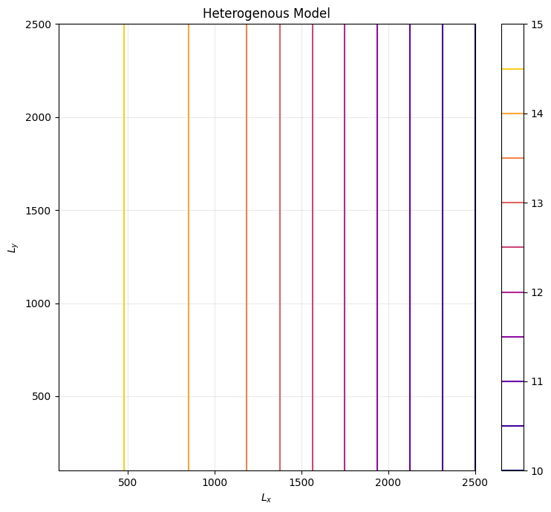

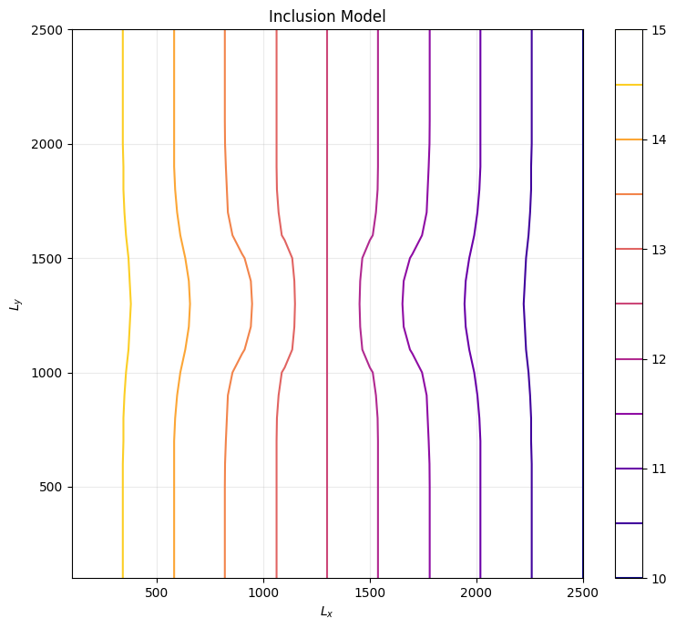

**\*\*\* I REALIZED I FORGOT TO PUT UNITS AFTER THE FACT (DOH!) \*\*\***